**ADBMS Practical**

Practical 7:CRUD using Neo4j

**1.Creating nodes Person,City and Hobbies.**

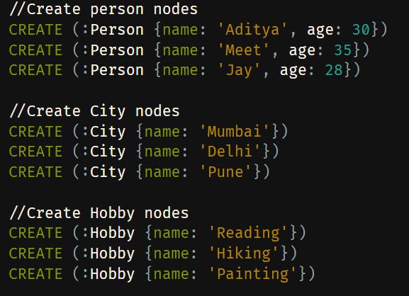

**2.Define Relationships**

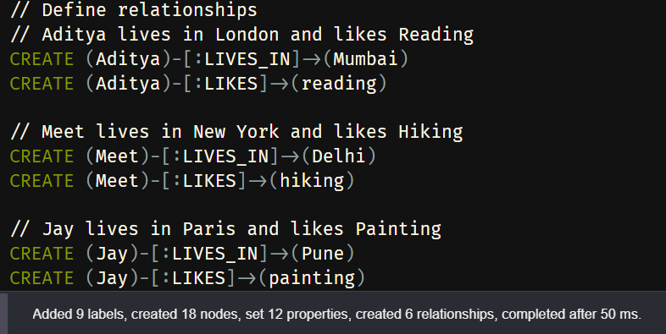

**3. Adding new Nodes and Relationships**

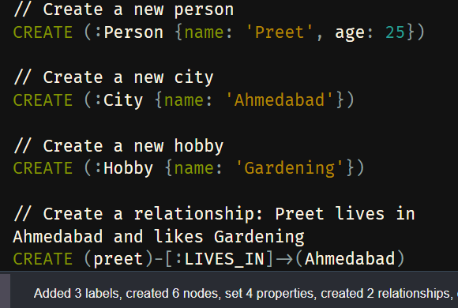

**4. Retrieving Data**

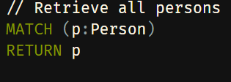

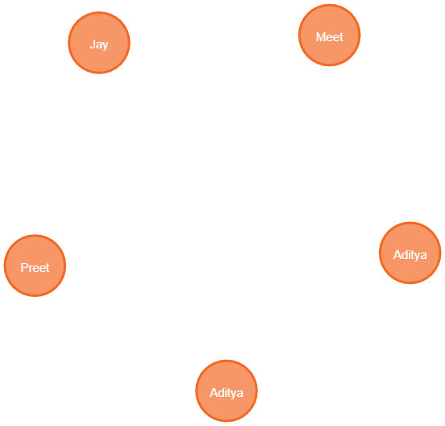

**5.Retrieving all cities**

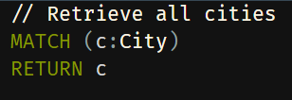

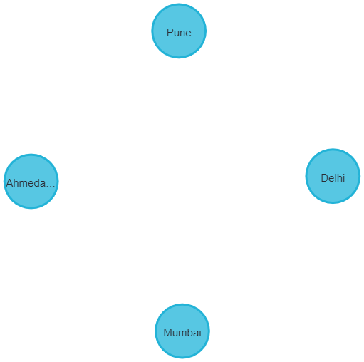

**6.Retrieving all Hobbies**

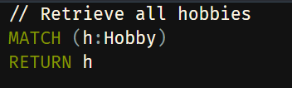

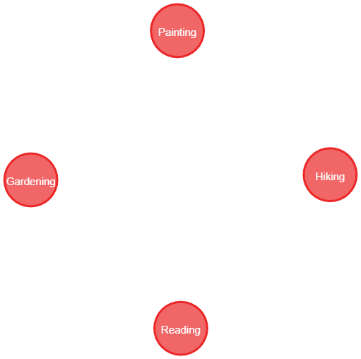

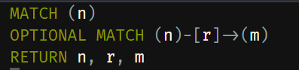

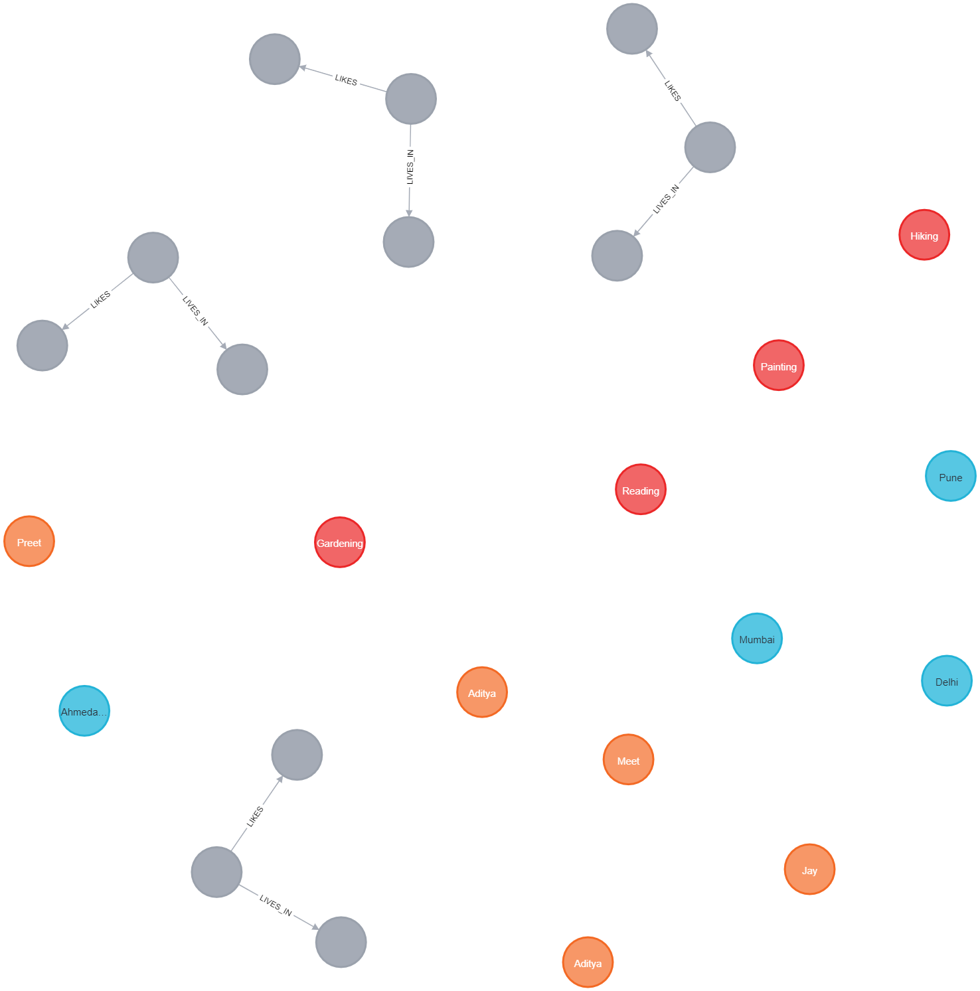

**7.Updateing the data**

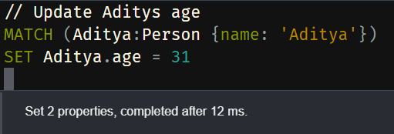

**8.** **Modifying Realtionships**

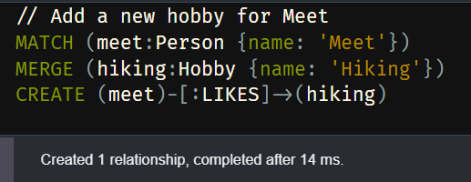

**9.Deleting nodes and relationship**

